# **Procedure CDP03 – Project Management**

# **Gantt Chart:**

We have divided the project into three parts. 30% project completion, 60% project completion and 100%. The following Gant Chart shows the overall project progress.

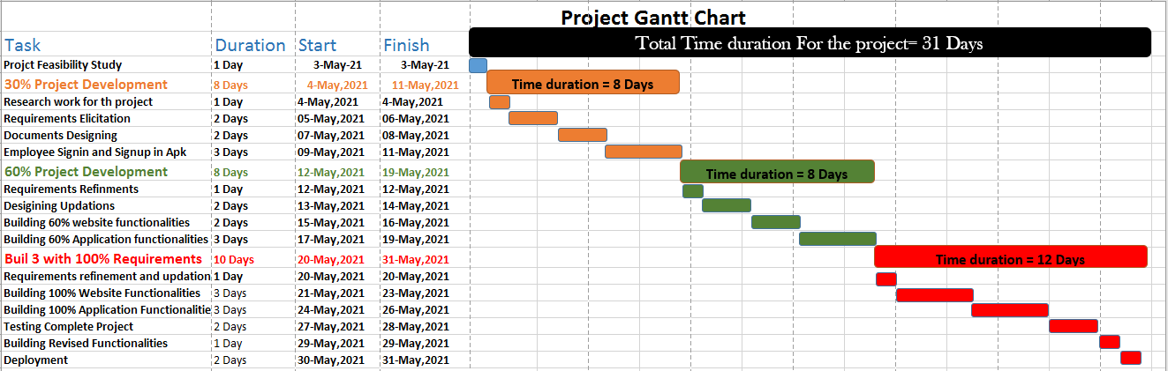

# **Risk Assessment:**

In any kind of project, it is possible that the stakeholders may face issues, problems may come, employees or the team members may leave, the client may come up with new issues. These all are the parts of almost every project, and these problems need to be handled in a proper way.

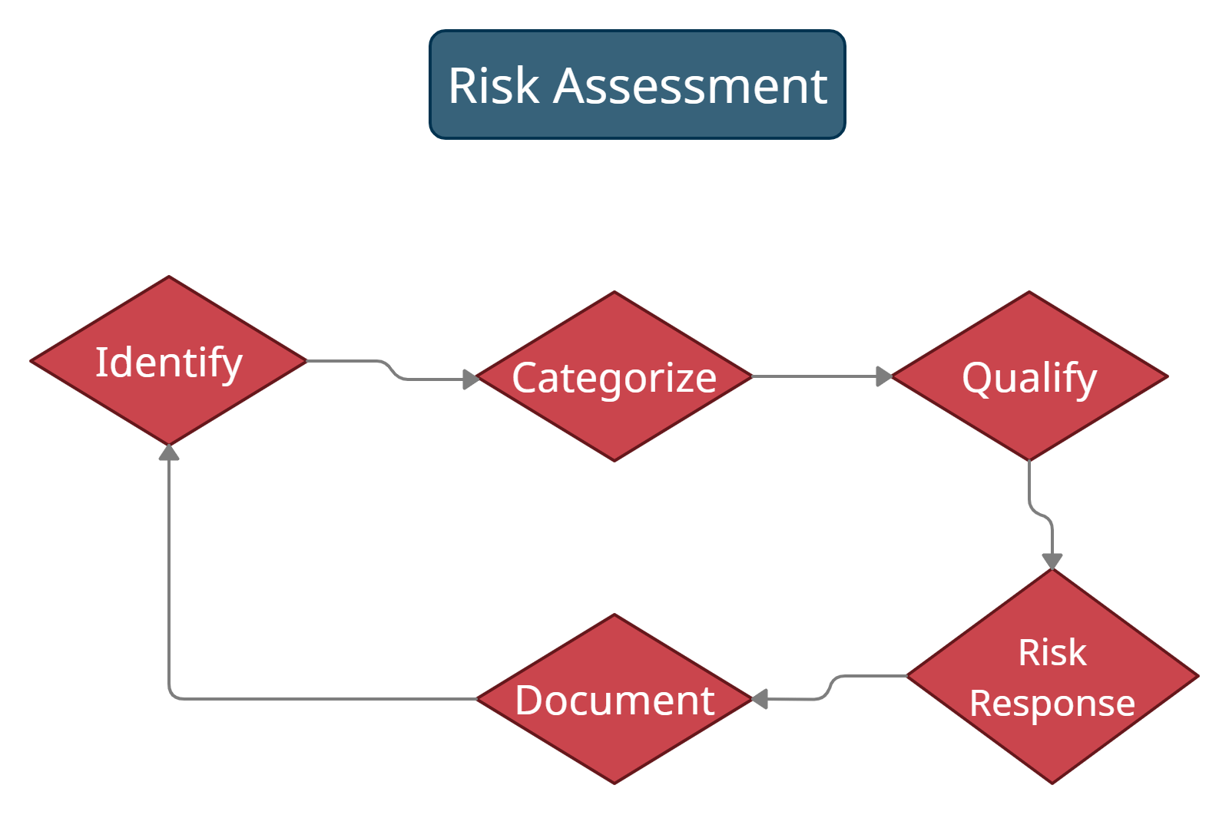

## **Risk Identification:**

For any kind of risks, first we need to identify the risk. Which kind of risks can we face in the project development.

Keeping the risks mentioned, we can have the following risks:

* Team members absence
* Team member illness for a long time
* Team member leaves permanently
* Unsuitable technology
* Loss of files
* Hardware failures
* Low feasibility chances
* Less technical team selection
* Poor Management
* Scope Variations
* Low Stakeholders’ engagement
* High stakeholders’ engagement
* Lack of ownership

## **Categorize the Risks:**

Categorizing the risks helps in better identification of the risks. Categorize the risks related to technologies, related to men power and related to the eco system of the project. It would help to avoid the duplication of risks, to properly define them and makes it easy to respond to these risks.

## **Qualify the Risks:**

Qualifying the risks means to give probability to the risks, how much it is the possibility that a risk will happen. Define a boundary for the risks, if that boundary is crossed it means the risk has happened in reality. Sticky notes help in the eco system to qualify the risks.

## **Risk Response:**

We also need to keep in mind that if a risk happens, what would be our response. The first thing is to follow different ways to avoid any kind of risk, but if it happens, what would be our strategy to solve it.

## **Document the risks:**

Once all these steps are completed, document the risks.

# **Impact of the risks on our Project:**

If a risk happens, it will undoubtedly affect our project. Following are some of the impacts that will happen if a risk happens:

* **Team member’s absences** affects the expected deadline of the project badly, it will also break the flow of the project and affect the other team members dependent on the tasks of that team member.
* **Team member illness for a long time** also affects the same thing, the project may get delay due to the dependencies on the team member.
* **If a team member leaves permanently,** the team will have to search for the replacement, new member would be needed, time will be wasted and the project budget may also get affected if the team is unable to find a new team member in the same budget.
* **Unsuitable technology** is kind of choosing a new or unproven technology that may lead to the project complexity, time delay, scope of the project and also budget of the project due to time delay. It may also lead to the termination of the project.
* **Loss of files** will have a serious impact on the project, it can ruin everything if any file like database etc. is lost at the time of deployment. It will affect both time and budget.
* **Hardware failures**, Somehow, we don’t have any hardware involved in our project, but hardware like tables in the environment or electric stuff failures. These are minor risks and do not affect the project too much.
* **Low feasibility chances,** Project may terminate if there is low feasibility.
* **Low technical team selection** will also affect the time delay and may be budget of the project in case if we needed to replace the technical team with experienced ones.
* **Poor management** affects the whole environment of the project, no one will be responsible for any kind of fault. It may affect the time delay of the project
* **Scope variations,** it will affect the actual scope of the project, with chances of project delay.
* **Low stakeholder’s engagement** will have impact on the scope of the project, functional requirements may miss.
* **High stakeholder’s engagement** will also have an impact on the scope of the project, the actual functional requirements may go to complexity.
* **Lack of ownership,** it is also a kind of poor management risk and can affect the environment of the project and team.

# **Possible solutions:**

* **Absences:** Proper policies would be defined at the time of team recruitment, holydays would be given to compensate with the team members to avoid absences.
* **Long term illness**, this is a kind of risk but team members need support in such conditions. Vocational rehabilitation can help them return to the work.
* **Team member leaves permanently,** Policy would be made that every team member should be bound to let the team leader or project manager know 1 month before leaving so the team gets time to work for the replacement of that member.
* **Unsuitable technology**, a complete study would be made, researchers would be involved in the study, last work about the project would be studied, after that technologies will be defined to avoid unproven new technologies.
* **Loss of files**, keeping backup of each and every file after a specific time period is the best solution for the loss of files. Autosaving option in some software must also be enabled.
* **Hardware failures,** electric stuff like extensions and laptops etc. can have faults at any time. We must keep alternates for them.
* **Low feasibility chances,** we will make a feasibility report before starting work on the project where each and every factor would be discussed.
* **Less technical team,** at the time of team selection, we will go through proper recruitment where technical skills of the candidates would be observed.
* **Poor management**, team would be made in a proper hierarchy like team leader, project manager, developers and all to avoid poor management.
* **Scope variations** can be handled at the time of scope definition. Study the project from every angle and define specific boundaries of the scope. In case if it varies, we must have a gap in time deadline and budget to fill up these issues.
* **Low stakeholder’s engagement** can result into missing of functional requirements. All the required stakeholders must be involved at any stage of the project development.
* **High stakeholder’s engagement** can lead to complexity. Only the required stakeholders must be involved in the requirements analysis and other stages of project development.
* **Lack of ownership,** a team leader or a project manager would be taking the responsibility to ask every team member to avoid lack of ownership and miss management.

# **References:**

1. <https://www.simplilearn.com/risk-assessment-project-management-article>
2. <https://www.researchgate.net/publication/236742385_Risk_assessment_in_project_management_a_practical_tool>
3. <https://www.researchgate.net/publication/4264846_Risk_Assessment_Framework_for_Project_Management>
4. <https://www.hrsolutions-uk.com/minimise-risk-absence-management-2/>
5. <https://codebots.com/library/way-of-working/what-are-the-10-biggest-risks-in-software-development>